CUPANICA
Bačka, Serbia
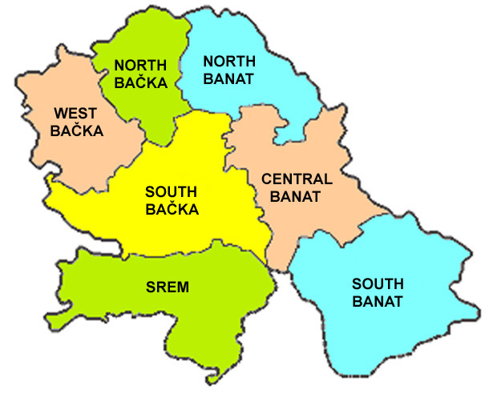
This dance comes from the Bačka region (also known as the Pannonian region) where the Croatian people live in the areas between the Danube and Tisa Rivers. In numerous debates and written articles about these people, they are often referred to as the Bunjevci and Šokci. The region is situated around the ancient town of Bač - which was once a district and also the seat of the Catholic Church. This is how it got its Slavic place-name. The migration of the Dalmatian Croats in the Bačka region (upon liberation from the Turks) did not happen at the same time. Their arrival occurred from the beginning of the 15th to the end of the 17th century. Despite the long period of their being among other Pannonian peoples, the Bačka Croats have survived and kept their speech patterns ("ikavian") as well as their wealth of costumes and art forms. This dance is done during wedding and other social gatherings. The bagpipe (gajde) used to be the traditional instrument played for this music; today the tambura orchestra is used.
The dance was learned by Željko Jergan in 1989 from village group from Tavankut at Đakovački Vezovi Festival.

TRANSLATION: Dance of the tiny bounce steps

PRONUNCIATION: TSUE-PAH-nee-tsah

CD: “BAŠTINA HRVATSKOG SELA” by Otrov, track # 20
“Sviraj Svirče Drmeša” by Skitnice, track #16

FORMATION: Cpls in a closed circle (or semicircle) facing ctr with hands or pinkies joined and extended fwd at shldr ht with elbows slightly bent. For M if a hand is free a fist is placed with the small of own back; W place a free hand with a loose fist on fwd part of hips with elbows pushed slightly fwd.

STEPS: Hops: Hops (lifts) are very small and do not leave the ground.

STYLE: Very elegant and danced upright with much dignity. Each step is small, slow and very deliberate. The women's style is always quietly consistent, while the men's steps increase in intensity and difficulty as the dance progresses.
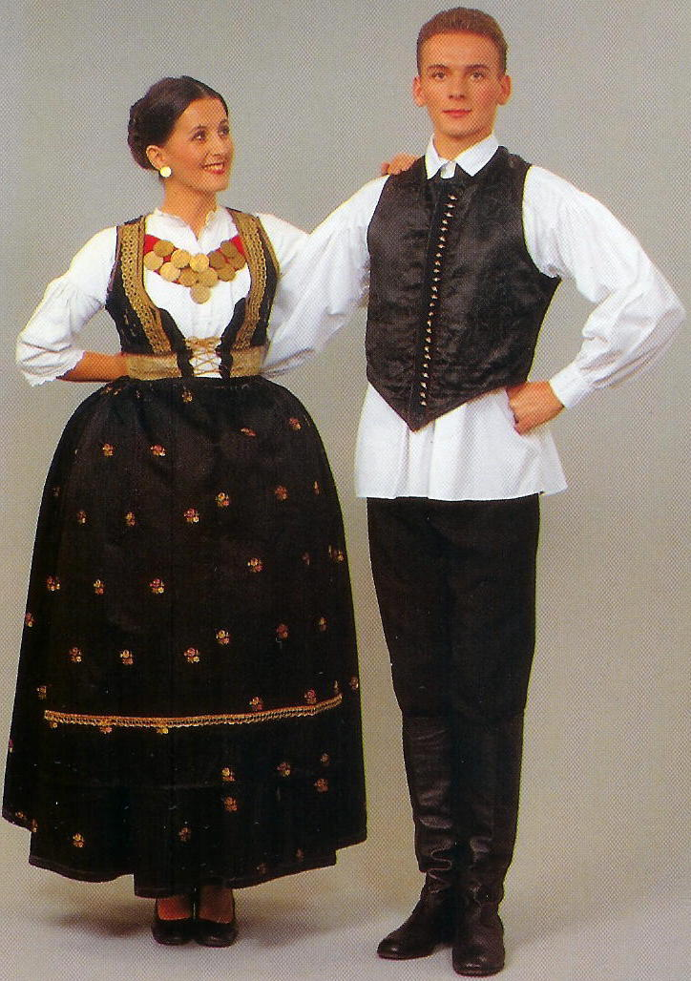

METER: 2/4 PATTERN
__________________________________________________________________________________________________________________
Meas.
INTRODUCTION: 4 meas (Otrov CD) - 3 beats (Skitnice CD)
BOTH M & W USE SAME FTWK

FIG. I: WALKS & TRIPLETS
1 Facing R of ctr and moving to R (CCW) - slowly walk R, L
(2 steps per meas).

2 Facing ctr - step R to R (ct 1); Step L behind R (ct 2).

3 Dancing in place on balls of ft - step R, L, R (cts 1-2-1); hop
on R in place as L lifts beside R no higher than ankle ht (ct 2).

4 Repeat meas 3 with opp ftwk. (LRL-hop)

5-8 Repeat meas 1-4.

Cupanica, Page 2 of 2

FIG. II: SIDE-CLOSE & TRIPLETS
1 Facing ctr and moving sdwd to R on balls of ft - step R to R & close L beside R (ct 1); step R to R & close L beside R (ct 2).

2 Repeat meas 1, 1 more time. (4 side-close in all).

3 Dancing in place on balls of ft - step R, L, R (cts 1-2-1); hop on R in place as L lifts beside R (ct 2).

4 Repeat meas 3 with opp ftwk. (LRL-hop)

5-8 Repeat meas 1-4.

M ONLY DO FIGS III TO V; W ALTERNATE DANCING FTWK OF FIG. I-II (No clicks)

FIG III: M - WALK & CLICKS (W dance Fig. I)
1-8 Repeat Fig. I, except when doing hop in place (meas 3-4), M click free ft to heel of weighted ft (click bells on heels).

FIG. IV: M - SIDE-CLOSE & CLICKS (W dance Fig. II)
1-8 Repeat Fig. II, except when doing hop in place (meas 3-4), M click free ft to heel of weighted ft (click bells on heels).

1-8 REPEAT FIG. III: M - WALK & CLICKS

FIG. V: M - SIDE-CLOSE W/CLICKS (W dance Fig. II)
1-2 Repeat Fig. II, meas 1-2 (5 side-close steps in all), except click L to R when closing ft.

3-4 Step R to R (ct 1); hop on R as L clicks to R (ct 2).
On balls of ft - step L to L (ct 1); close R to L with click (ct 2).
On balls of ft - step L to L (ct 1); click R to L (ct 2).

  - Repeat meas 1-4, except replace last click with a step R in place (ct 2).

**** Repeat dance from beg. Dance is done a total of 2 times!



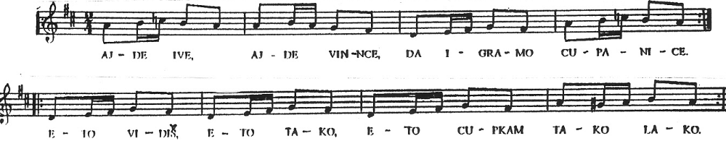
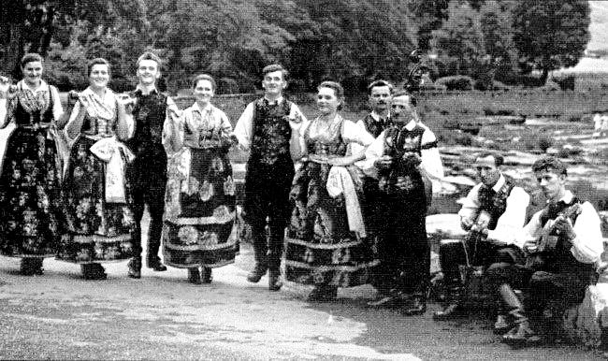
AJDE IVE, AJDE VINCE, DA IGRAMO CUPANICE.
ETO VIDIŠ, ETO TAKO, ETO CUPKAM TAKO LAKO.

AJDE STIPE, AJDE MARKO, NEK’ ZAIGRA SUNCE ŽARKO.
ETO VIDIŠ, ETO TAKO, ETO CUPKAM TAKO LAKO.

Let’s go John! Let’s drink some wine and dance Cupanica.
You see how easily and gracefully we are dancing.
Let’s go Steven; let’s go Mark; let’s dance beneath the bright sun.
You see how easily and gracefully we are dancing.

Dance notes by Željko Jergan, 10-01

